
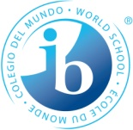
My Reflection about my MYP Project

Name Jeronimo Guerra
Project Group 6D

1. I learned…
How to work in teams, express my ideas and to hear others ideas

2. I need to look into…
Organization and time

3. It was difficult for me…
To hear others ideas and accept them

4. My next step will be…

